**Excel Assignment - 9**

**1. What are the different margins options and do we adjust the margins of the excel worksheet?**

*There are some predefined margin settings like Normal, Wide, Moderate, Narrow etc in Ms Excel.*

*But Custom Margin settings are also possible in Ms Excel. To specify custom page margins, click Custom Margins and then—in the Top, Bottom, Left, and Right boxes—enter the margin sizes that you want.*

**2. Set a background for your table created.**

*Click Home > Format Cells dialog launcher, or press Ctrl+Shift+F. On the Fill tab, under Background Color, pick the color you want. To use a pattern with two colors, pick a color in the Pattern Color box, and then pick a pattern in the Pattern Style box.*

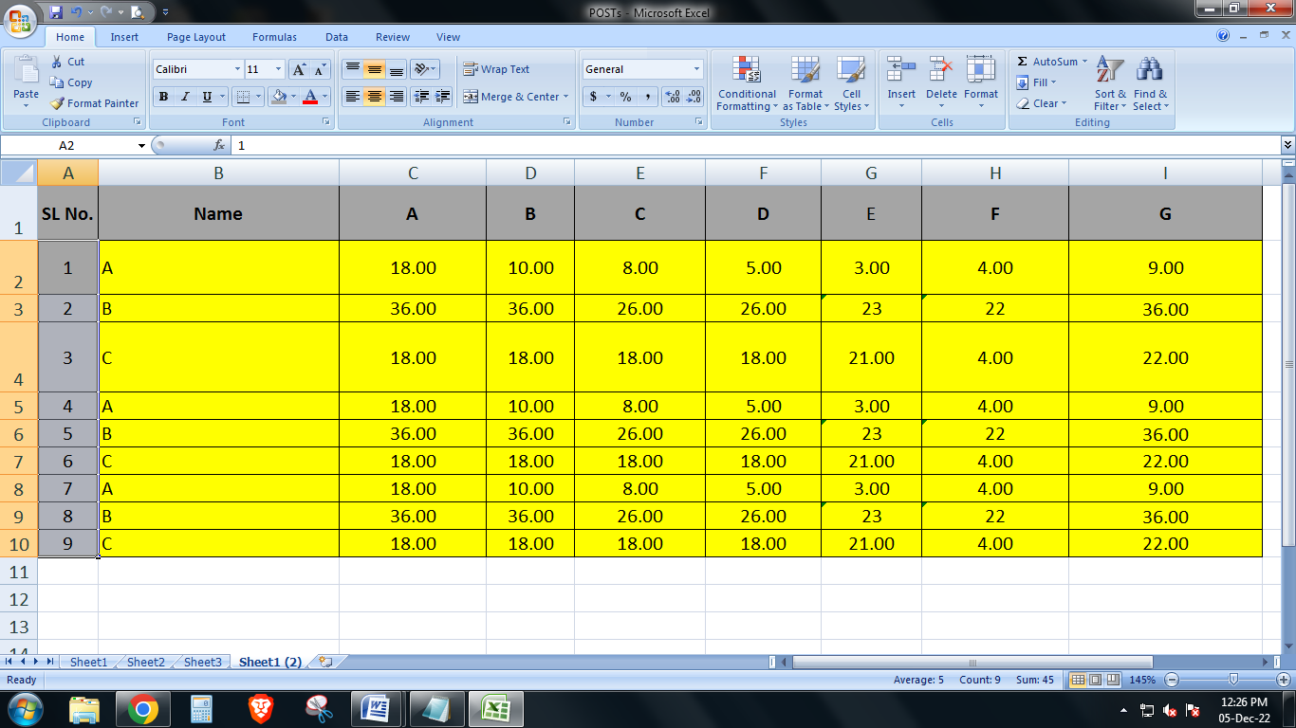

**3. What are freeze panes and why do we use freeze panes? Give examples.**

*Freeze panes are used to keep an area of a worksheet visible while we scroll to another area of the worksheet.*

*To use this feature go to the View tab, where you can Freeze Panes to lock specific rows and columns in fixed place of the worksheet.*

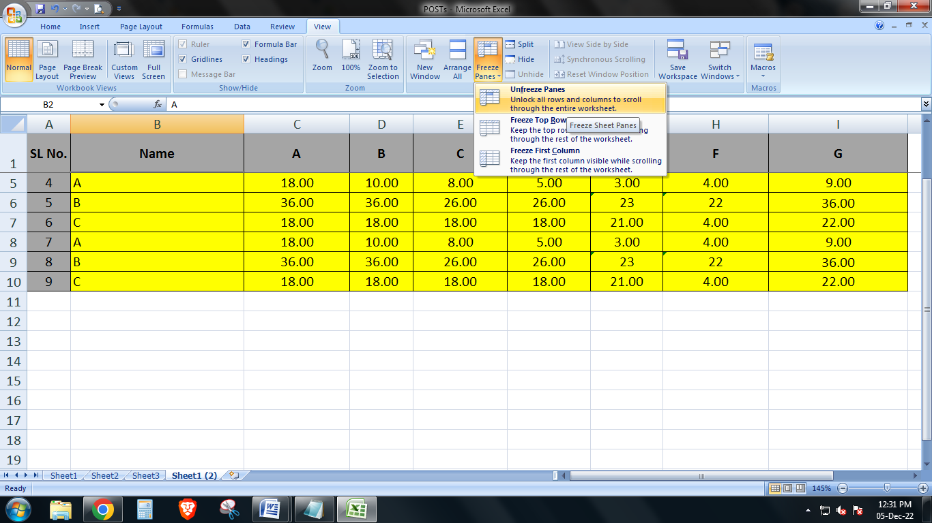

**4. What are the different features available within the Freeze Panes command?**

*It shows three options in the Freeze Panes drop-down:*

*Freeze Panes: It freezes the rows as well as the columns.*

*Freeze Top Row: It freezes all the rows above the active cell.*

*Freeze First Column: It freezes all the columns to the left of the active cell.*

**5. Explain what the different sheet options present in excel are and what they do?**

*Insert - As soon as we click the Insert, the new blank worksheet will appear in the current workbook.*

*Delete – It is used for deleting the remaining sheets will give a professional and clean look to our workbook.*

*Rename- We can rename any worksheet and change the default sheet name to any desired name to better reflect its content.*

*Move or Copy- When we need to duplicate the data from one sheet to another in Excel, we can use the Move and Copy option from the right-click sheet options list. We must first right-click on the sheet that we wish to copy and then select the 'Move and Copy' option. Click the checkbox next to the 'Create a copy' option to duplicate the content without deleting the original content.*

*View Code- If we wish to launch VB Editor using the 'View Code' option on any sheet tab, Excel will open a code window for that specific sheet. Therefore, this option to launch VB Editor is mainly useful when writing code that will work only for a particular sheet. For example, creating worksheet events*

*Protect Sheet-* *After clicking the protect sheet, Excel will display another window to set preferences for locking purposes. Additionally, we can set a password that will restrict others from unlocking or unprotecting the sheet*

*Tab Color- To change the color of the sheet's tab, we need to select the Tab Color option from the list that we get after right-clicking on the sheet's tab. Next, we must click on the desired color, and it will be immediately applied to the selected sheet tab.*

*Hide- This is to hide a sheet, we need to click on the Hide option from the list of right-click sheet options. As soon as we click the Hide option, the corresponding sheet will no longer be visible on the sheet tabs.*